Perla Garcia Cavazos
Module 3 Normalized Tables Assignment

Assumptions
- A publisher can publish many books.
- A book can have multiple authors, and an author can write multiple books → this requires a junction table.
- Contact information belongs to the entity it describes (publisher or author).
- ISBN uniquely identifies a book.
- No derived fields (e.g., no “full name” stored — only first/last).
3NF Table Structure

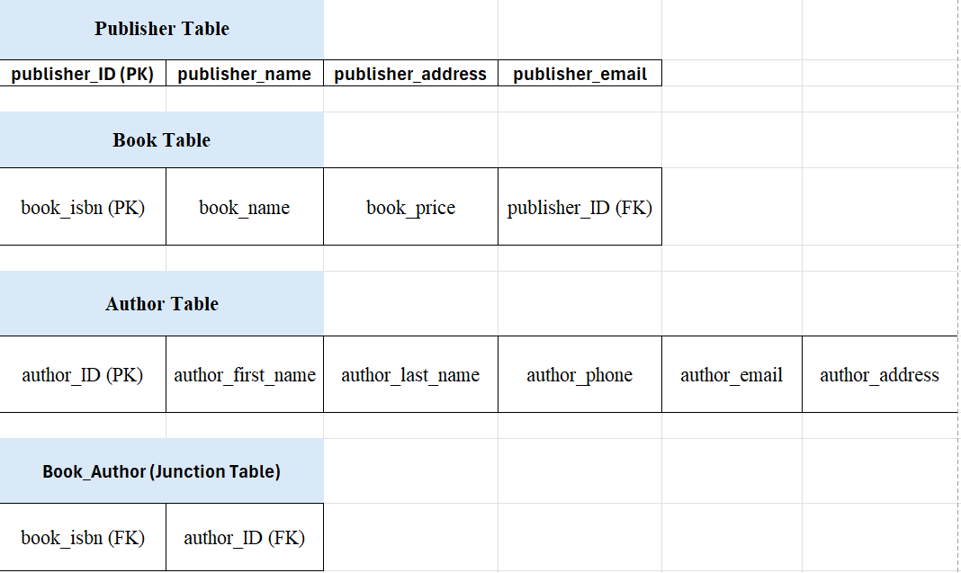
Figure 1: Normalized Tables in 3NF — adds a polished touch.

This resolves the many-to-many relationships between books and authors, which is required for 3NF.

Why This Is 3NF
- 1NF: All fields are atomic (no repeating groups, no multi-value fields).
- 2NF: All non-key attributes depend on the whole key (especially in the junction table).
- 3NF: No transitive dependencies — contact info belongs only to the correct entity, and no field depends on another non-key field.

